Project Management

Assessment ONE

John in wells college

|  |  |  |  |
| --- | --- | --- | --- |
| Name of Student | Sourng Ly | ID | 18219 |

**Assessment 1 – Case Study**

Contents

Instruction: 1

Duration: 1

Case Study: 2

Going Green application, Green IT Project Management 2

Project profile 2

Business situation 3

Your tasks: 4

Task 1: Identify Business Strategy and Gap 4

Analyse Strategy 4

Task 2: Recommend a feasible solution 5

Task 3: Produce a Project Charter 5

Task 4: Project Document 7

Task 5: Project Closure 9

Helpful web links to complete the assessment: 12

Search Index 13

## Instruction:

This task is to be completed individually. You need to analyse a case scenario and complete all the tasks mentioned after the scenario.

You need to demonstrate your IT project management ability to identify business strategy and gaps. You will also need to suggest a feasible solution to overcome identified gaps and produce a project charter along with a WBS to implement the proposed solution.

### Duration:

Trainer will set the duration of the assessment.

All my working could be checked <https://sourngma.github.io/PmT32023byS/>

## Case Study:

### Going Green application, Green IT Project Management

# Project profile

Going “Green” is a mission of many companies around the globe not just for reasons of environmental responsibility, but also for cutting costs in these extremely tight economic times. Green IT efforts represent a specific focus area within enterprises that hold attention to this trend. Green IT leverages information technology to streamline operations, cut costly waste, and reduce the impact on the environment. IT typically consumes only about 10% of an organization’s energy costs, but the net effect of a Green IT project is to go beyond just energy saving. To tackle the other 90%, a Green IT project extends into a variety of other departments, and to execute such an endeavour requires an effective project management function in order to identify and prioritize goals. A Green IT transformation can be a complex process.

Vital Statistics:

* Number of project tasks - 12
* Project duration - 16 months
* Project budget - $1,200,000
* Number of users - 50

Because I could not get Ms-Project software. I use Google Sheets to made Gantt chart template:

I also think using a simple case, which I knew well, could be better for my learning. Go to website:

Link URL: <https://docs.google.com/spreadsheets/d/1p1nF3VFw3u3r3iSOUi9kLgw_s2H_zSYHHED7RsKD6NE/edit?usp=sharing>

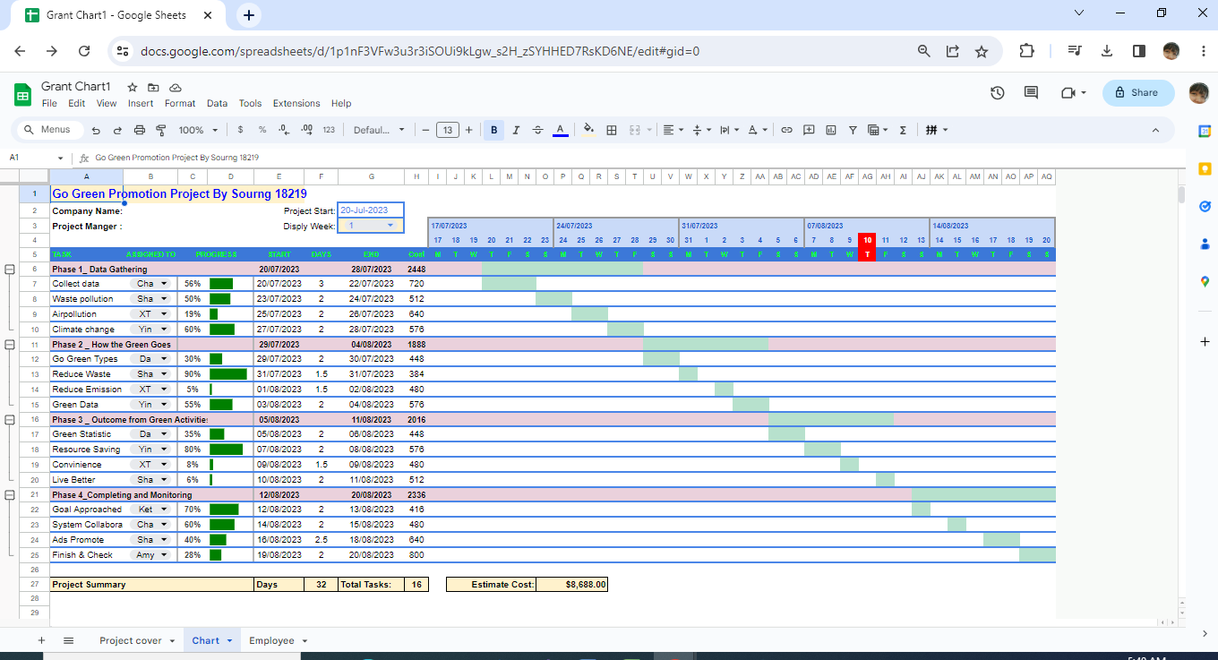

Or using GantProject Software

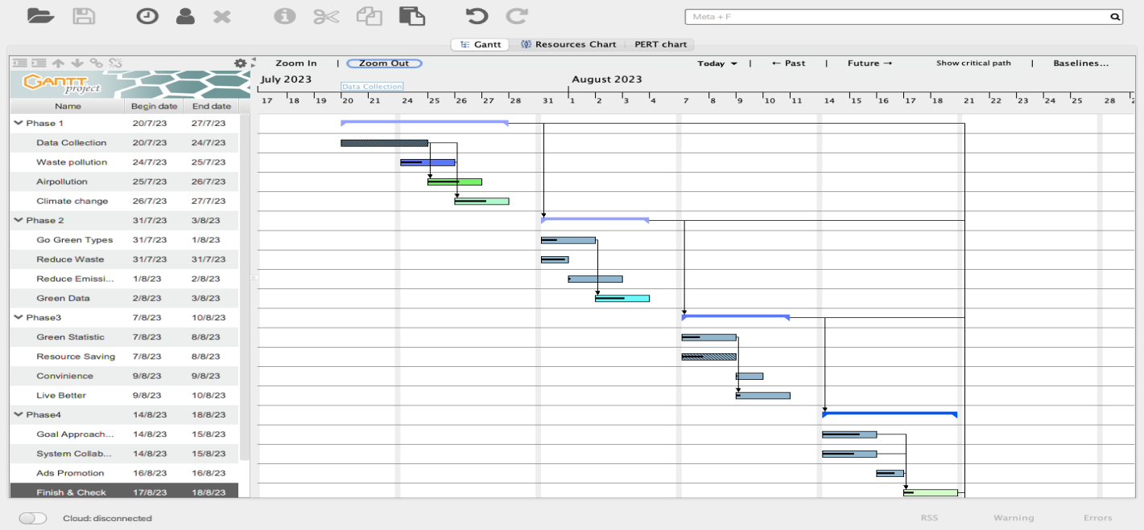

### 

### Business situation

In order help college promotion, the college need good video film. I set the project and start it now……

## Your tasks:

### Task 1: Identify Business Strategy and Gap

Document the business’s strategies of “Green IT” and also summarise the components required changes for the participating organisation to implement “Green IT Project”. (Min. 300 words)

Business strategy is a planning function of any organisation. Business strategy incorporates having a strategic plan. The identified refers to the long-term goal or roadmap for an organization, and how are the plans to reach them. And also it’s a path towards its goals. However, tactics is important for specific actions to be set to reach the organizational goals, or strategy. The Green project would be leveraged technology on daily practices to reduce cost and as well as resources and increasing work efficiency by going green. All the set up should be attractive and convenient for internal and external stakeholders. Optimizing existing IT assets and resources, these require all departments involve and participate. As the recent business situation the organisation strategy would be needed many individual task support of the Green IT Project such as Sever Virtualization, Server Power Capping, Active Power Management, Alternative Energy Plan, Computer Hardware Recycling, Data Center Chargeback Model, Data Center Cooling and Airflow, Energy efficient Coding Practices, Measure Data Center Energy Use, Printer and Display Efficiency, etc. The Gap would be occur in this transition project, based on the strategy to look into the gap and find a better strategy by do adjusting and align the strategy accordingly. Analyse the unique services or practices that are recently successful by asking stakeholders and approach works. Some unique ideas become obsolete over time because of having a new way of obtaining what they need due to technological advancement. Think critically about the using experience and what the new strategy would affect with the changes their using and experience. Try to understand recently existing services and trends then encourage people involve the new project and let them understand what is the new would make them more convenient and efficient outcome. Surveys and listen feedback are important for inspiration to adjust the gap and apply a better strategy. Establish producing a lot with very little waste coding practices, do some related to computers and science investments for measure total data center energy uses and finally be paperless and energy savers turning off the screens when the workers are away.

### Analyse Strategy

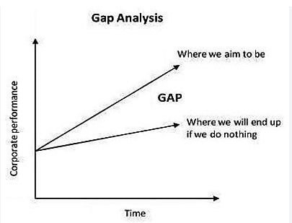The strategic plan of an organisation sets out the goals a business hopes to achieve within a specified period of time. It also helps the organisation understand the environment within which they operate and the market forces that affect them.

An analysis of the current strategic plan enables you to understand the goals of your organisation. However, in order to analyse the strategic plan, you first need to understand the structure and purpose of a strategic plan. This topic describes the elements that make up a strategic plan.

The green project we need defined every requirement. The gap which is between your plan and reality always need your notice. So you need do your best to investigate your Green Project.

### Task 2: Recommend a feasible solution

Assume “Wells International College” is thinking of going “Green” and asked for your assistance in this project. Research different project management applications on the Internet to compare with the Green IT project management application and recommend a feasible solution with proper reasons for Windsor. (Min. 300 words)

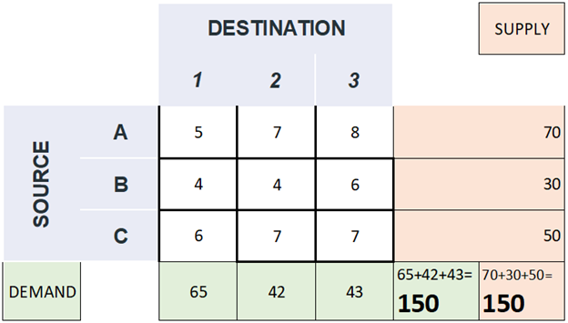

See above simple example. Any destination, Supply must equal to demand or very close. It is the best business solution. The feasible solution is obviously show demand and supply must be close, which means all resources are used efficiently and do not waste the resource and save time save cost as well as labour or worker. Find out the demand or market needs then satisfy the market to increase services or sale. Adjust the strategy on supplies and resources to the most requirement destination. The project strategy would be going through with time, goal and cost. These three essential elements are related and affect to each other. For instant, if the time goes too long, it would affect goal, but if reducing time, it would affect cost as require working overtime or extra ordinary working hours. Hence these three elements must be suitable and adequate with the project purpose, budget and acceptable period. Let’s go to talk these three elements in details. Identify the gap by analysing find out our strength, weakness, opportunities and implication. Likewise, Go Green project, the project aims at promoting the awareness about environmental issues and sustainable development. For school go green project the same aims with Green IT are paperless and technology support for daily working practices. The project related to promotion and provides convenient services to stakeholders; these would encourage and involve them in our go green project. Facilities and resources should be recycling oriented, resources efficiency used and saving any waste from work like printing out unnecessary paperwork, buying overused stationary and hardware. Water, electricity, etc. using is also should focus as these wasting energy is the big problem our global facing, to do this saving and recycling is saving cost at the same time. In conclusion, go green project between “ Wells international college” and Green IT has the same goal and related procedure or method to go through, somehow Green IT would be focus more on reducing technology coding and other related energy supplies provide to customers or users and employees as well.

### Task 3: Produce a Project Charter

Please view my project charter (here only show part):

My Google sheet for the project: <https://docs.google.com/spreadsheets/d/1p1nF3VFw3u3r3iSOUi9kLgw_s2H_zSYHHED7RsKD6NE/edit?usp=sharing>

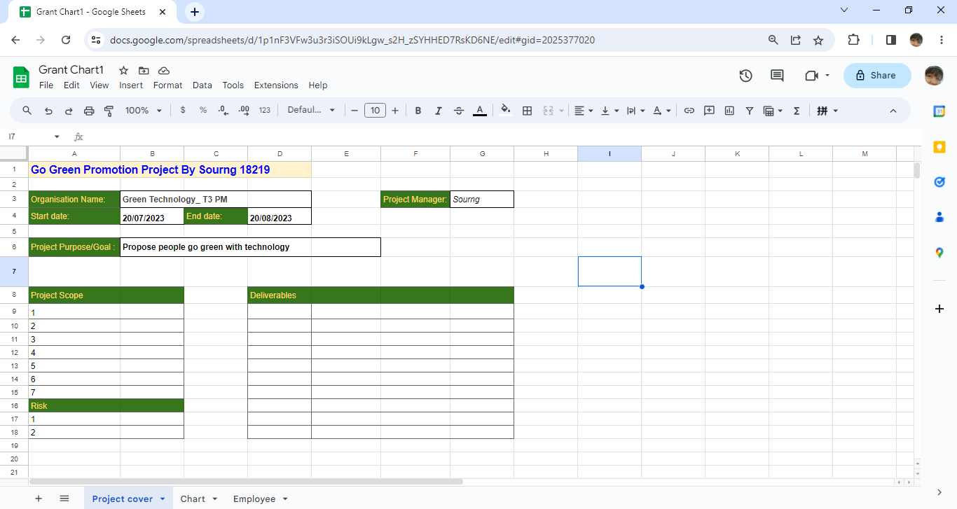

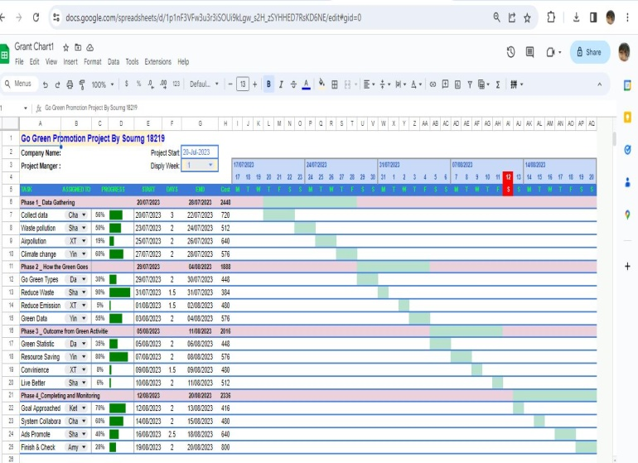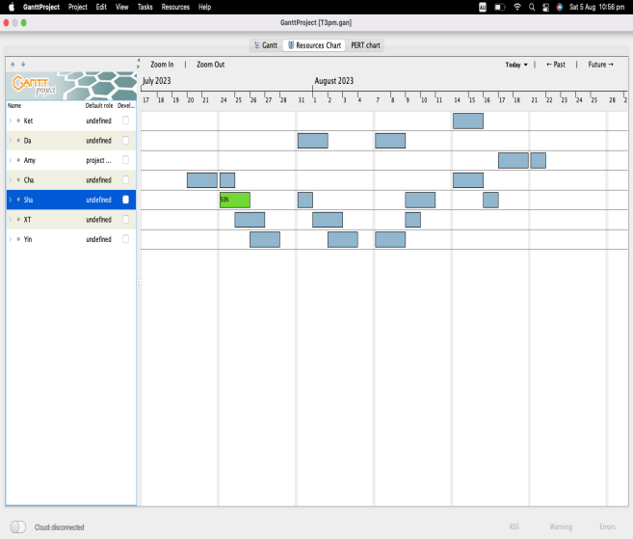

Develop a project charter for the Windsor project specifying project start date, finish date, approximate budget, project manager, project team with roles and responsibilities, project objective, project approach and stakeholders.

Name: Go Green Promotion

Description: Help business and propose people go green with technology

Manager: Sourng

Start date: 20 July 2023; Finish date: 20 August 2023

Date Approved: 18 July 2023

Scope : Phrase 1: Data Gathering

Phrase 2: How the Green Goes

Phrase 3: Outcome from Green Activities

Phrase 4 : Completing and Monitoring

Stakeholders: All departments and Customers

### Task 4: Project Document

Please check my site: <https://sourngma.github.io/PmT32023byS/>

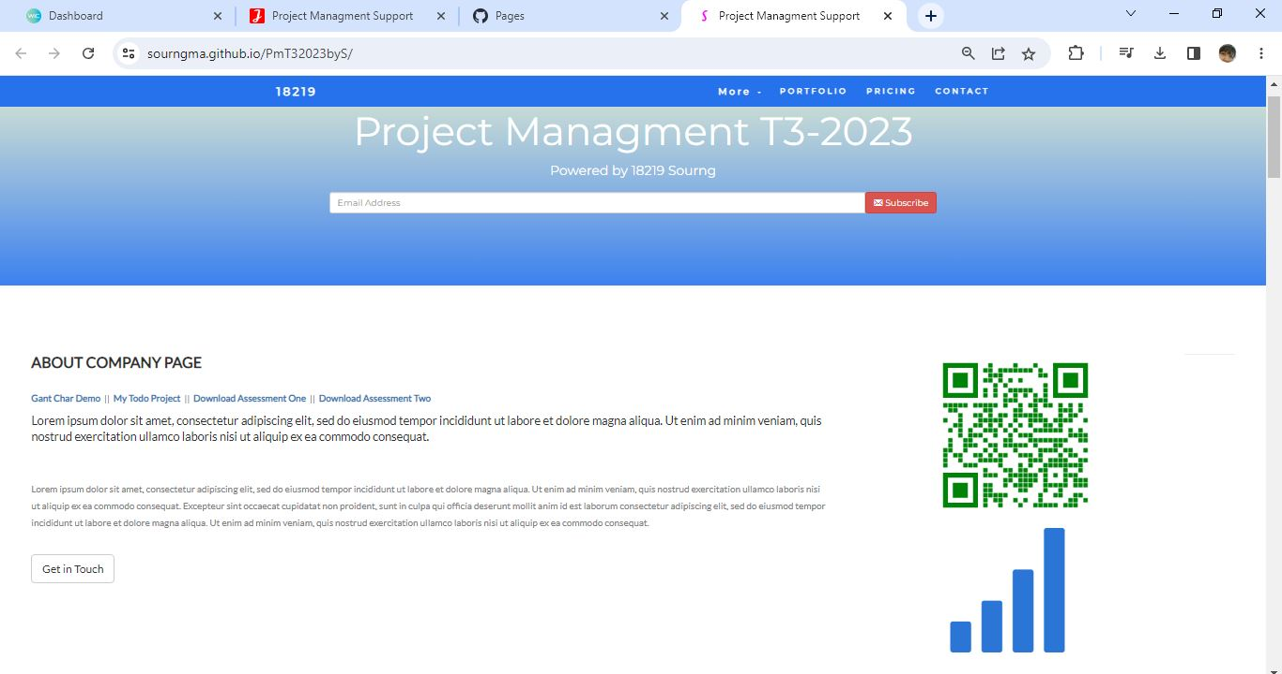

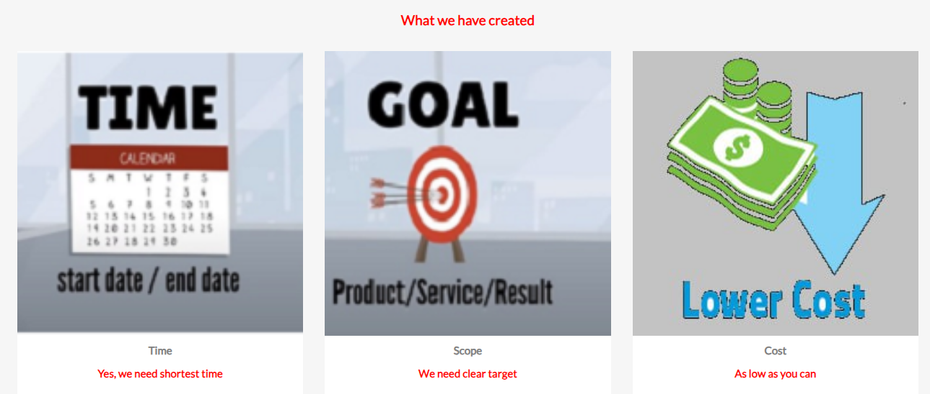

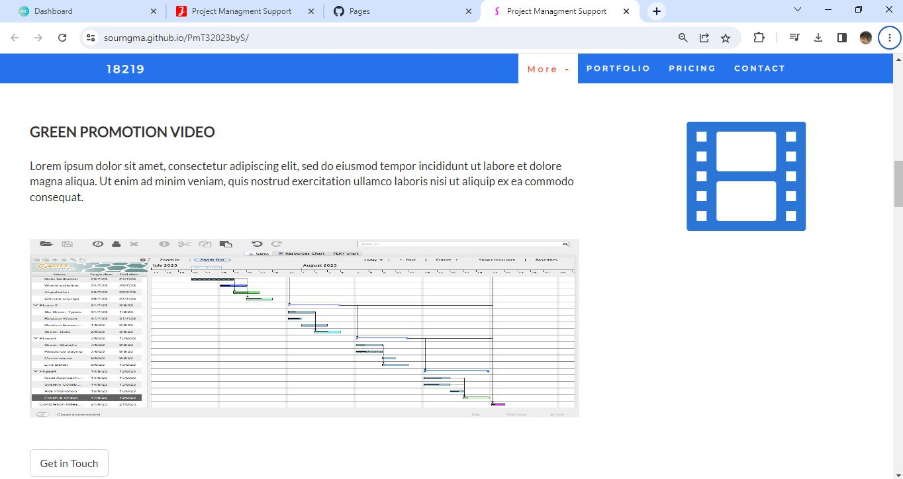

Refer to your current project, you have been asked to develop a project plan for WIC. Project plan outline as following:

In my Green project, I design following topics:

* Introduction (Select one recommendation from Task 2 for implement project plan)

**(Please see above my project charter, it is clear indication)**

* Project background

**(Make promotion video for the college)**

* Related factor to organization
* Scope and objective of the project
* Information gathering plan and approach
* Gathering method, can be one of the following
* Interview
* Questionnaire
* Observation
* Detail of information repositories
* Feasibility studies
* Technical **(need higher tech made this software more stable and powerful)**
* Operational
* Economical
* Social
* Project plan and schedule (Development and Maintenance)
* Work breakdown structure
* Gantt Chart
* Milestone

Above last black diamond is the milestone!

* Project Deliverable
* Communication plan

Communication plan should include communication and consultation with all the relevant stakeholders. (From college learn guide)

* Deployment Plan (If needs)
* Training Plan (If needs)
* Recourse and budget, (budget has been limited by WIC Capital Expenditure of current fiscal year for Hardware $80,000, Software $10,000, and Outsourcing man-hours $100,000)

Above image is showing my current green project displaying part of budget!

* Risk Management
* Risk identified
* Contingency plan
* Change management
* Change control
* Conflict management

### Task 5: Project Closure

Prepare project closure document template as following:

* Project Sign-off document

When project sign off, it means your project finished. So you need make one clear sheet to tell everyone about your project. It will include:

* project start date
* project manager
* project finish date
* if something is going wrong
* ...

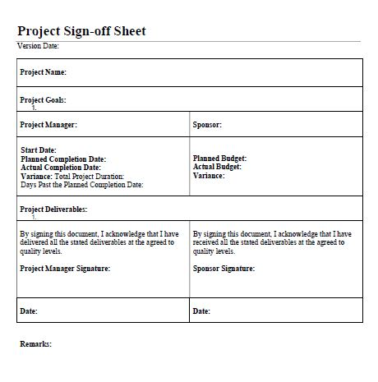

* Project evaluation document

You need show about your project, good or not enough. Summary all about your project

It may include:

* Budget evaluation
* Quality evaluation
* Benefit evaluation
* Etc...

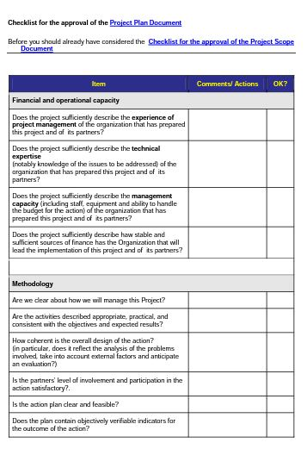

* Lesson learned template
* What we have learn through this project
* What we need to do if next project start
* What we learn some lesson. We could not make same mistake again.
* Etc.

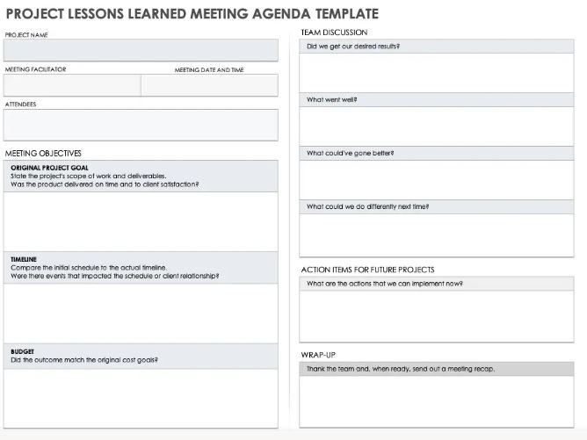

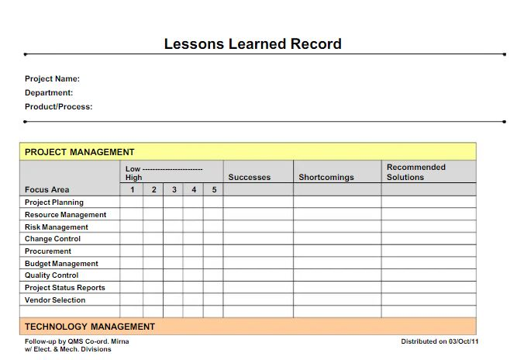

## Helpful web links to complete the assessment:

1. <https://www.youtube.com/watch?v=8eKk0M2zGIk>
2. chrome-extension://efaidnbmnnnibpcajpcglclefindmkaj/https://elearning.wic.nsw.edu.au/pluginfile.php/41690/mod_resource/content/2/Learners_%20Guide_Project%20Management.pdf
3. <https://www.lucidchart.com/blog/5-Universal-Project-Management-Principles>
4. <https://www.wrike.com/project-management-guide/faq/what-are-the-principles-of-project-management/>

## Search Index

B

Benefit evaluation 10

Budget evaluation 10

F

feasible solution 1, 4

P

project sign off 9

Q

Quality evaluation 10

S

same mistake 10

scenario 1

specific focus 2